MANAGEMENT INFOTMATION SYSTEM

LAB EXPERIMENTS

PAGADALA ASHOK(192110152)

2. Draw a coffe coffe day ordering system. A coffe coffee day shop vending machine  dispenses coffee to customers. Customers order coffee by selecting a recipe from a set  of recipes. Customers pay for the coffee using coins. Change is given back, if any, to  the customers. The ‘service assistant’ loads ingredients (coffee powder, milk, sugar,  water, chocolate) into the coffee machine. The ‘service assistant’ adds recipe by  indicating the name of the coffee, the units of coffee powder, milk, sugar, water,  chocolate to be added as well as the cost of the coffee. The service assistant can also  edit and delete a recipe. Develop the use case diagram for the specification above**.**

**Aim:**

To develop a **Use Case Diagram** for a **Coffee Day Ordering System**, representing interactions between customers, service assistants, and the coffee vending machine.

**Procedure:**

1. **Identify Key Actors:**
   * **Customer**: Orders coffee and makes payments.
   * **Service Assistant**: Manages coffee machine ingredients and recipes.
   * **Coffee Vending Machine**: Processes orders and dispenses coffee.
2. **Define Use Cases:**
   * **Customer Use Cases:**
     + Order Coffee
     + Select Recipe
     + Make Payment
     + Receive Change
     + Receive Coffee
   * **Service Assistant Use Cases:**
     + Load Ingredients
     + Add Recipe
     + Edit Recipe
     + Delete Recipe
   * **System Use Cases:**
     + Dispense Coffee
     + Process Payment
3. **Establish Relationships:**
   * The **Customer** interacts with the **Coffee Vending Machine** to **Order Coffee**.
   * The **Customer** selects a **Recipe** and makes a **Payment**.
   * The **Machine** checks the recipe and **Dispenses Coffee**.
   * The **Machine** gives **Change** if required.
   * The **Service Assistant** loads **Ingredients** and manages **Recipes**.

**Output:**

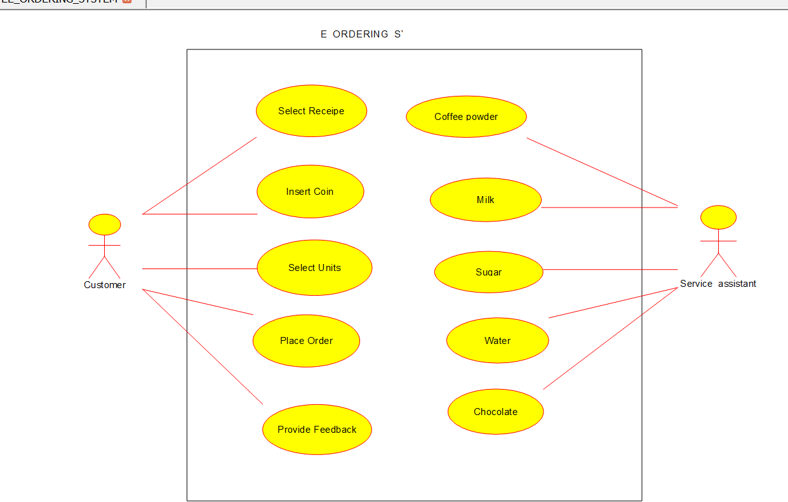

**Use case diagram**

**Result:**

A **Use Case Diagram** will be created based on the above analysis.